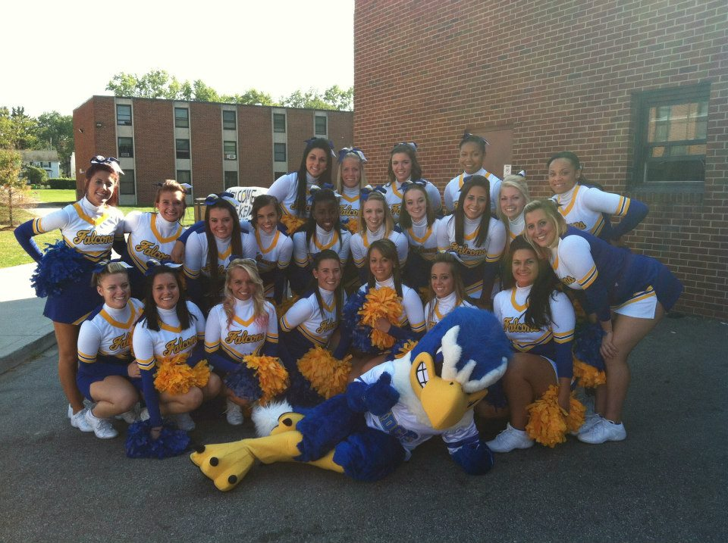NDC



Participant Name: _______________________________________________________

School: ____________________________________ Age: _______________________

T-Shirt Size: Please specify if youth or adult: ___________________________________

Parent Name: ___________________________________________________________

NDC Cheer Clinic

June 22nd 2013, 9-3

Murphy Gymnasium, Keller Center

**Interested in improving your cheer skills? Come learn from the NDC Falcon Cheerleaders!**

Notre Dame College Cheerleading is pleased to announce their youth clinic on June 22nd 2013 from 9am – 3pm in the Murphy Gymnasium, Keller Center, on the campus of Notre Dame College. The clinic is designed for cheerleaders ages 5-14 and participants will be split by skill level. Throughout the day clinic participants will learn motions, jumps, 2 chants, 2 cheers, and 2 dances. The level of difficulty and length of material will be determined by skill level. Parents will have an opportunity to watch a showcase of the day beginning at 2:30pm. Instructors are members of the NDC Falcon Cheer Team. Clinic leader is Assistant Cheerleading Coach Allison Kokely.

**Schedule for the day**

Participant check-in will begin at 8:30am. Parents will be required to leave after check-in. Promptly at 9:00am clinic instructors will begin the camp with stretching, jumps, and motion drills. These skill sessions will be followed by the teaching of the camp material: 2 chants, 2 cheers, and 2 dances. At noon cheerleaders will break for lunch. After lunch participants will learn the remainder of the material in preparation for the showcase. Parents are encouraged to return at 2:30pm for the group performance. The clinic will conclude at 3pm.

**What to bring**

Participants will be required to where appropriate athletic attire and athletic footwear. Hair is to be pulled back and jewelry and piercings are to be removed. Stud earrings are acceptable. Cheerleaders are also responsible for packing their own lunch and should bring a water bottle. If the weather is appropriate cheerleaders should be prepared to spend time outside. Please pack sun tan lotion, hats, etc. if this is a need for the participant.

**Registration**

Clinic cost is $25 and this INCLUDES a camp shirt. To complete registration please return this form, waiver, and include a money order or check made out to Notre Dame College and mail to NDC. Registration deadline is June 8th. Missed the deadline or have questions? Contact Coach Allison Kokely at 216-409-2676 or via email at [akokely@ndc.edu](mailto:akokely@ndc.edu).

Address to mail registration material:

Notre Dame College Cheerleading

4545 College Road

South Euclid, OH 44121